**Ideation Phase**

**Define the Problem Statements**

|  |  |
| --- | --- |
| Date | 19 September 2022 |
| Team ID | PNT2022TMID23607 |
| Project Name | Smart lender-Applicant credibility prediction for loan approval |
| Maximum Marks | 2 Marks |

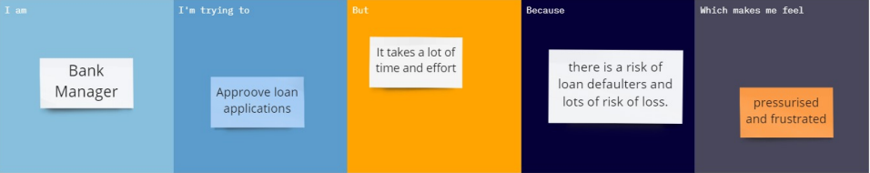

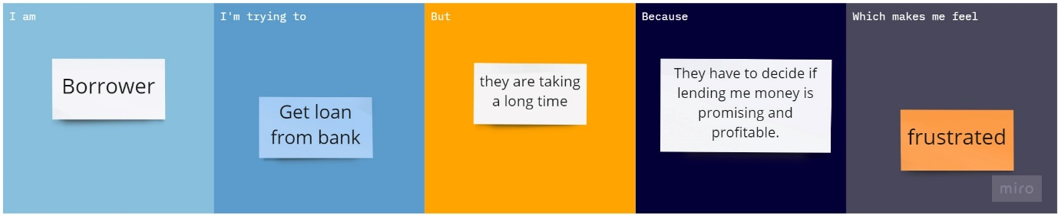

|  |  |  |  |  |  |
| --- | --- | --- | --- | --- | --- |
| **Problem Statement (PS)** | **I am (Customer)** | **I’m trying to** | **But** | **Because** | **Which makes me feel** |
| PS-1 | Bank Manager | Approve loan applications | It takes a lot of time and effort | There is a risk of loan defaulters and lots of risk of loss | Pressurised and frustrated |
| PS-2 | Borrower | Get loan from bank | They are taking a long time | They have to decide if lending me money is promising and profitable. | frustrated |